**Problem 3d)**

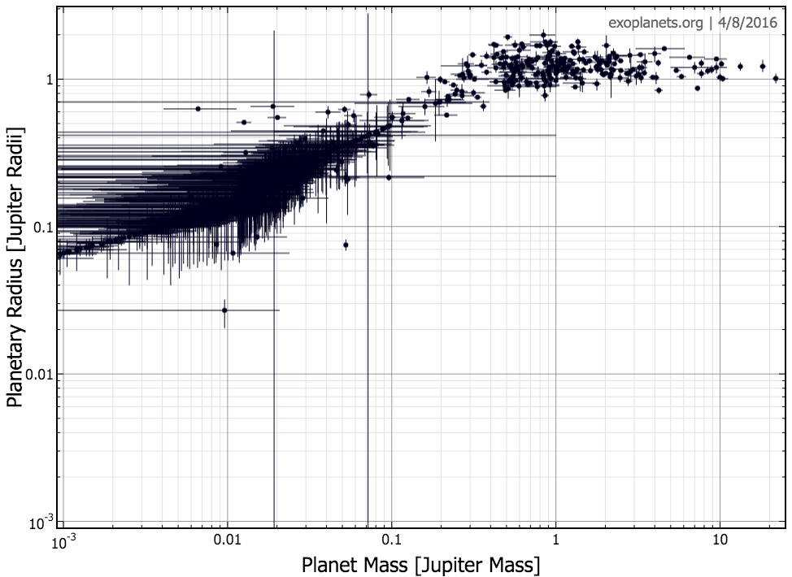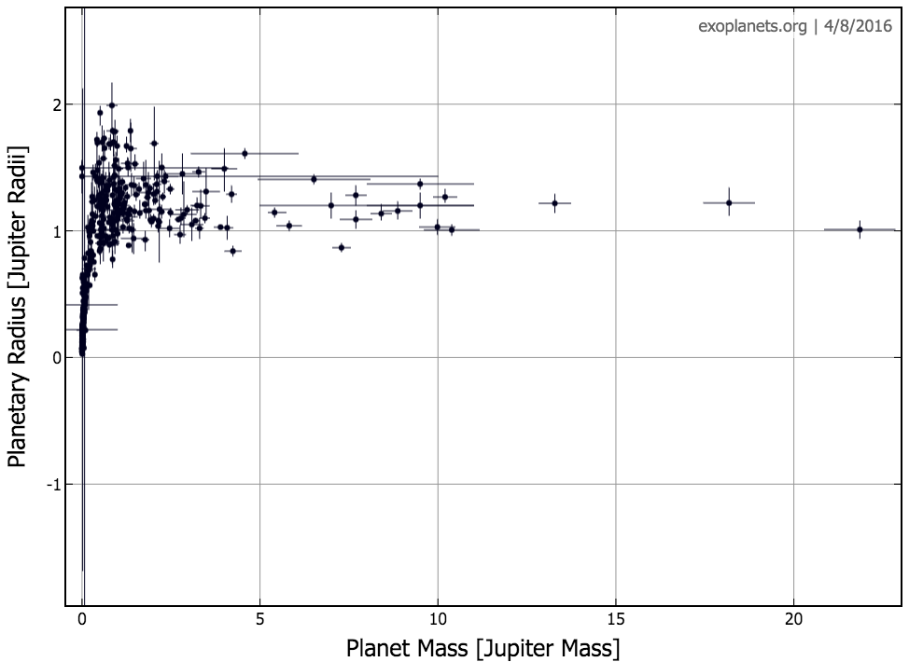

The error bars are quite significant for the sub-Neptune planets. We cannot, therefore, be confident about the properties of these planets from this data. The horizontal spread in mass with similar radius indicates planets of varying density. Since it ranges from gas giants to rock/ice planets, we expect a reasonable spreads across radii. This is more to be expected at sub-Neptune levels, where gas and non-gas planets are more or less equally likely, rather than gas dominating.